# Lab 3: Introduction to Graphics

Academic Honesty

* The work you turn in is to be your work, not copied from someone else, from the web, or generated by a program.
* Never allow anyone access to your files.
* Never give anyone your password.
* Never share your USB memory or email your files to anyone else.
* Never give anyone a printed copy of your file or an electronic copy.
* Never allow anyone to copy your work.

Purpose

This lab will let you practice using graphics and drawing shapes. You will have to think about shapes and angles.

## Functionality

* Draw a House and Stick figure as shown below.
* Both shapes will be different colors.
* Your program will look similar to the picture below (All components will be present)
* If your picture doesn’t look good (e.g. house is lopsided) you will lose points
* Comment your code, indicating which sections is for the roof, frame, door, window… This will make it easier to read your code.

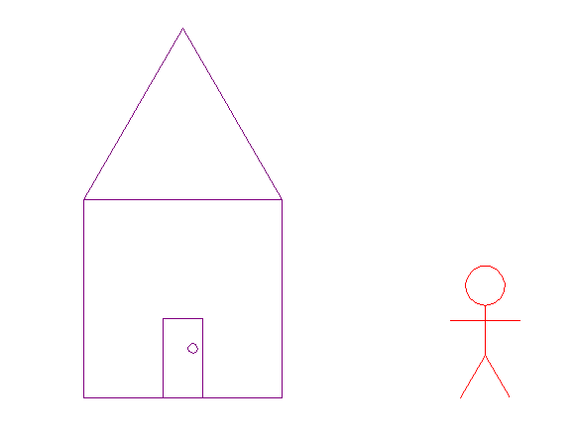

## Extra

You will receive up to 90% for completing the basic functionality as outlined above. To receive the last 10% you will add something extra and substantial. E.g. Windows on the house, a face on the stick figure, shoes on the stick figure, hair on the stick figure…

Add a comment in your code to indicate what you did extra.

## Submitting your files

* Copy your .py file and move it to your X:\101Labs directory for grading.
* Make sure your file is named Lab3XY.py where XY are your initials
* Print your code, and submit it to your lab instructor at the beginning of your next lab class.

## Grade Breakdown

|  |  |
| --- | --- |
| **Points** | **Expectation** |
| 10% | Comments, listing program, your name, explaining the code, breaking the code into sections |
| 40% | Correctly draw house |
| 40% | Correctly draw stick man |
| 10% | Extra |